Createit User Notes
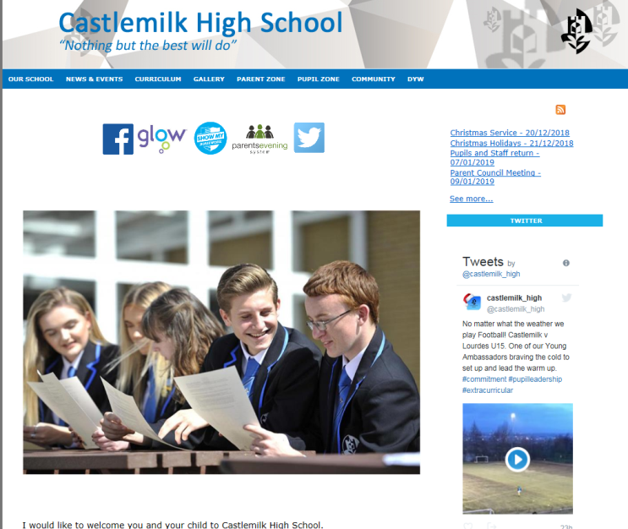
Createit is a Content Management System which allows users to create a unique, engaging and useful website without any specialist knowledge.

www.createitplus.co.uk

Contents
Creating content for your website 3
Logging in/Managing accounts 3
Section 1 – Uploading content Uploading documents and images 3
Uploading videos 4
Uploading your logo 4
Uploading a header background 4
Section 2 - Organising your website 5
Subsections 5
Adding a subsection 6
Adding content to a calendar, news or gallery section 6
Adding entries to a calendar 6
Adding stories to your news section 6
Adding an album to a gallery 7
Adding images to the album 7
Selecting the front cover for your album 8
Adding plain text sections 8
Updating or deleting a plain text section 8
Arranging text in a plain text section 8
Section 3 – Creating your website homepage 9
Adding contact details to homepage 9
Adding Latest News with Summary to homepage 9
Adding calendar to homepage 10
Adding images to your homepage 10
Adding a slideshow to the homepage 11
Adding a Twitter feed 11
Section 4 – Designing your homepage 12
Changing colours 12
Changing Font 12
Appendix 1: Look & Feel – Colours 14
Appendix 2: Look & Feel – Fonts 15

Creating content for your website
Please access the Createit Website Admin area here. You can also paste in the URL address into your browser - http://admin.createitplus.co.uk

Logging in/Managing accounts

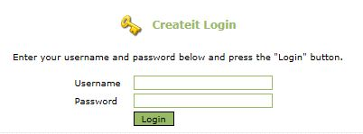
When you access the site, you will be asked to login, using the Username and Password that you have been issued. On your first visit you will be prompted to change your password. You can view/change your details at any time by clicking onto My Account from the homepage.
You will then be taken to your homepage and you should click on My Website, which is the 2nd menu on the top of the screen.

You are now ready to start working on your website. The first step is to add files and images that you are going to use as content on your website.

Section 1 – Uploading content
Uploading documents and images
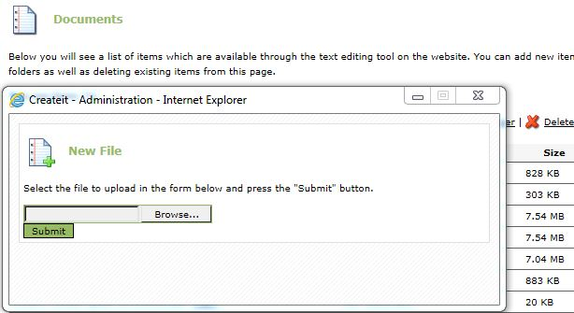
The process for uploading and managing documents and images for your site is the same.
- Click on My Website then Documents or Images.
- Click on the Upload a new file link which will open a dialog box to browse and find the file you wish to upload.
- It is best to organise your content within a folder for ease of navigation.
You can create folders to store your files by clicking on the Create a new folder link. This will open a new dialog box asking for the folder name, to add files to the folder click on the folder name before you click the Upload a new file link.
There is also an option to Upload multiple files.

Uploading videos
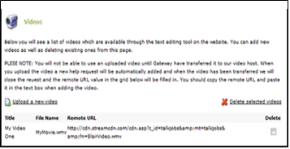
You can add videos to your site. Videos should be in wmv, mp4, avi or QuickTime format, and must be no larger than 30mb. Uploading the video is the same as for images and documents.
Before the video can be used it will be uploaded by Gateway to a hosting company. This will allow your video to be streamed improving the experience for your users. Once this task has been completed, you will see the Remote URL in the video area.
To add a video to a page you will need to copy the Remote URL from the videos page and paste it into the Movie Properties dialog from the textbox.

- Click on My Website > Videos.
- Copy the Remote URL of video you wish to use.
Go back to My Website and Site Update Wizard or Front Page.
- Navigate to where you want to insert video.
- Click on the Media player icon and paste in the Remote Url that you copied.
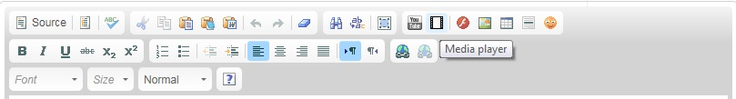
- Click ok then save.

Uploading your logo
- Click on My Website then My Logo.
- Use the Browse button to find the folder where the file containing the logo is stored.
- Click on the Upload Image button to place the updated logo on the site.
- Logos should be no larger than 220 x 70 pixels. *Please note that a newly updated logo may take up to 30 minutes to appear on your site.
- In order to replace the logo with another one you cannot
- In some templates there is a sample logo already in the header and you need to upload your logo which will replace the existing one.

Uploading a header background
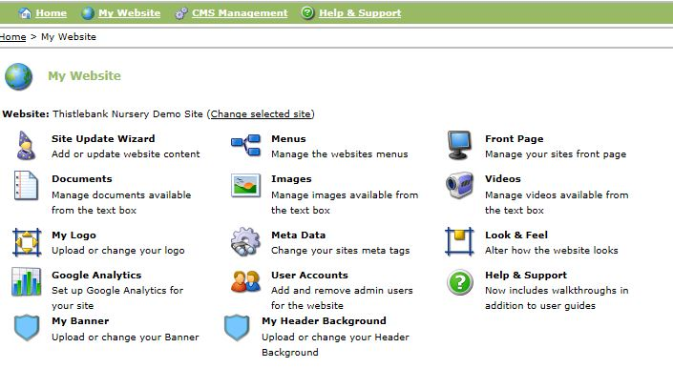
When uploading an image for your banner there are two options depending on the template you are using.
If you are on an older template, you will select My Banner (no other option available).
For those on the 2019 responsive template, you will select My Header Background.

When you upload a banner, some of the image may be cut off or distorted as it is stretched too much. Play about with images to see what works best. For example, landscape will work better than portrait.

Note: 2019 Responsive Template is set up so that a logo must be attached. If you would like this removed, please contact Gateway and we can remove it.

Section 2 - Organising your website
Menus
The template starts you off with some main headings added. These however can be deleted or edited, and you can add more. Please note: Once you have added a new heading, it will not appear live on your website until content is added.
Click on My Website and select Menus. You will see a list of the menu headings. These correspond to the main headings already on your website.
Please note: Menu headings will appear on your website in the order they have been added, so plan carefully how you want them to appear before adding.
Adding a new top menu
- Click in Title box under New Menu Item and add new heading.
- Make sure Live is ticked.
- The new heading will not appear live on the site until content has been added.
Updating a top menu name
- Click Update on the menu you wish to change. The title will appear in the bottom right hand box.
- Edit Title then click Update Item.
Deleting a top menu
- Click Delete next to the menu you wish to remove. The title will appear in the bottom right hand box.
- If you are sure you wish to remove this heading, click Delete Item.
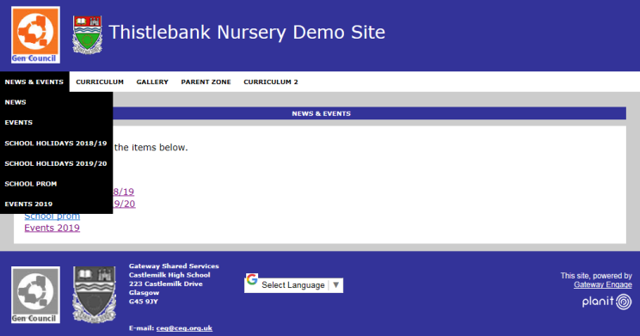
Please note: If you want to change the order of any menu or sub menu titles, please contact a member of staff at Gateway.

Subsections
Once you have added all your main headings, it’s time to decide what will appear under each of these main headings. These are called subsections. When a subsection is added, it can be added as Plain Text, a Calendar, a Gallery or News.

Adding a subsection
Step 1:
- Click on My Website and select Site Update Wizard.
- Select Option 1 to add a new section. Choose content type from drop down menu.
- Plain text – copy and paste a Word document, type in text or insert tables and images.
- Calendar – add a school calendar.
- Gallery – add photo albums. You could have for example, a gallery named after each year group or each term.
- News – add news items or upcoming events.
- Click Proceed with wizard and create new section.
Step 2:
- Give your subsection a title. Some examples of subsections are School Holidays 2019/20, News, Events, Staff, Photos 2018/19, School Handbook 2019/20, Visions & Aims. It is completely up to you and is individual to each site.
- Enter text in text box. You may wish to copy and paste text and images from a Word document you already have.
- Click next at bottom right hand corner. At this point you will be asked which main heading you wish this to go under.
- Select Item and click Finish.

Adding content to a calendar, news or gallery section
If you selected Calendar, News or Gallery as your content type, you will now need to add content.

Adding entries to a calendar

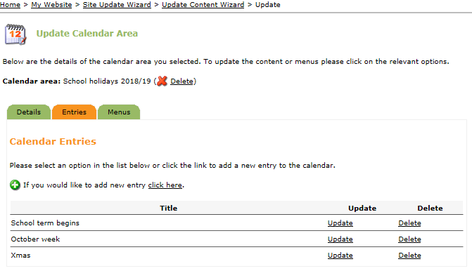
- Click on My Website and select Site Update Wizard.
- Select Option 2 – update or delete existing content.
- Click Pick Me from the top level menu your subsection is under.
- Select the calendar by clicking Update/Delete.
- Select the Entries tab.
- Select if you would like to add new entry click here.
- Type in a brief description of the holiday or event then select a date from calendar.
- In the text box you can type in a brief description or attach a link to booking forms or documents about the event for parents.
- Select Add Entry.
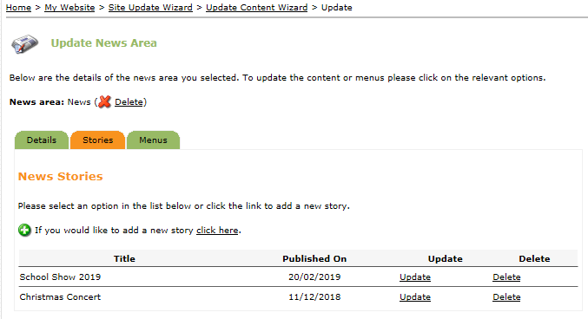
Your now have an entry in your calendar. You can continue to add further entries this way until your calendar is complete. You can also edit or delete existing entries this way.

Adding stories to your news section

- Click on My Website and select Site Update Wizard.
- Select Option 2 – update or delete existing content.
- Click Pick Me from the top level menu your subsection is under.
- Select the your news section by clicking Update/Delete.
- Select the Stories tab.
- Select if you would like to add a new story click here.
- Type in a title.
- Upload a Summary image which will display on the homepage if you decide to add the news and events summary option.
- Type in archive date if applicable (it will no longer display once this date passes).
- Add the content of the news item in the text box.
- Click Add Story.

You now have a news entry. You can continue to add further stories this way. You can also edit or delete existing stories this way.

Adding an album to a gallery
- Click on My Website and select Site Update Wizard.
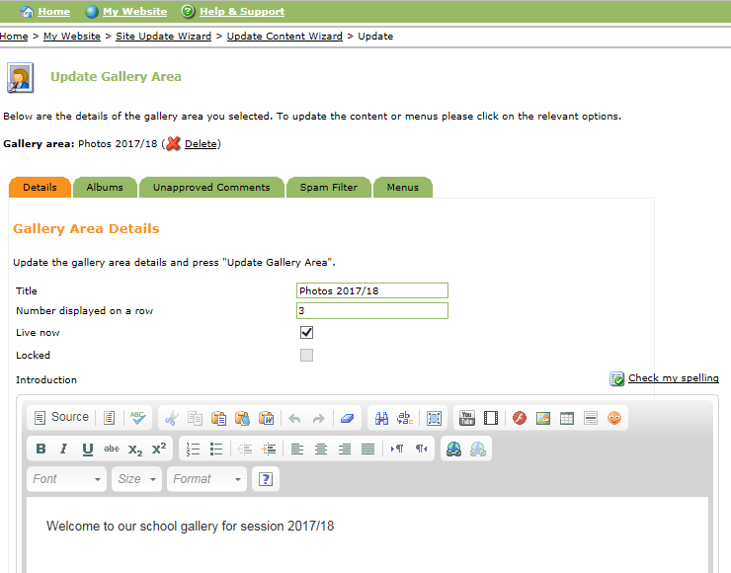
- Select Option 2 – update or delete existing content.
- Click Pick Me from the top level menu your subsection is under.
- Select the your gallery by clicking Update/Delete.
- Select Albums from the tab options.
- Select if you would like to add new album click here.
- We recommend that you don’t allow comments on the images.
- Type the number of images you would like to appear per row (3 is probably standard).
- Type in brief description of the content of the album.
- Click Add Album.

Now you have an Album you can add images to it.

Adding images to the album
- Once you have added an album to your gallery, click go back to gallery area details (or through My Website and Site Update Wizard as above).
- Select Albums from the tab options.
- Select Images beside the album you wish to add photos to.
- Click on if you would like to add new image click here (same process as Uploading documents and images above).
- Browse for the image, select it and then Add Image.
- For adding multiple images clicking on if you would like to add multiple images use the multiple uploader.
- Click Add Files, select all the images you wish to upload.
- Select Open.
- Click Upload Files.
- A page is displayed to confirm that you have uploaded the images successfully.

Selecting the front cover for your album
- Select the album.
- Click on Images.
- Click Highlight to choose the picture you wish to appear on the front cover of an album.

If you do not wish to create an Album you can opt to organise your images within a table in a text box area. This process is described within the next section. This means that your images will be visible on your website without going into an album icon.

Adding plain text sections
Plain Text pages will make up the majority of your site. When adding content you will use a textbox that has many of the formatting options you will be used to from creating Word documents.
- Click on My Website.
- Select Site Update Wizard.
- Select Option 1, add a brand new section.
- Select plain text from drop down menu.
- Click on text Proceed with wizard and create new section.
- Enter Title.
- Type in your content, or copy and paste from an existing Word document.
- Click Next then select which main menu you want the page to appear under.
- Click Finish.

Updating or deleting a plain text section
- Click on My Website.
- Select Site Update Wizard.
- Select Option 2 to update.
- Select the main menu the plain text section is located in.
- Select the your sub menu by clicking Update/Delete.
- Update information as required or to delete click ( Delete).
- Click Update Text Area.

Arranging text in a plain text section
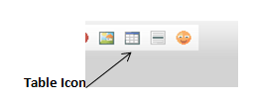
You can add a table within a text box to help organise your text – this is useful for items where you are mixing text and images, for example, staff lists.
- Click on the Table icon.
- Enter the number of rows and columns.

You can now use these boxes to arrange your text and pictures, which will ensure a formatted approach, for example, staff list.
- Click in the box on the table where you want the image to appear.
- Click on Image icon (directly to the left of the table icon).
- Choose a specific image clicking Browse Server (select image from images uploaded), click Finished then OK.
- The image will now appear within a box in the table.
- You can repeat this process as many times as necessary and the box will automatically resize the table to fit the page (ideally this should be no more than 3 or 4 images across).
- You can then add text to these pictures by entering text in the row below or in a column to the side.
- Once you have the table completed and you are happy with the layout you can hide the lines for a more professional look.
- To hide the lines, click right mouse button within the table and choose Table Properties.
- Enter 0 in the border size box then OK.

Linking documents/websites in a plain text section
You can link a document you have uploaded by selecting Option 2 in the Site Update Wizard and select a section to update.
You can link a document (or website) to text, an image or a photo.
Highlight some text, image or photo then click the Link icon from the toolbar.
In the Link dialog box you can either, link a document by selecting Browse Server and selecting a document you have uploaded, or copy and pasting a website address (URL) if you want to link to another website or to another part of your site.
Please note: To link to a document you must have already uploaded it to the documents section of Createit.

Section 3 – Creating your website homepage

Now you have all the content for your website and have created your menus - you need to create your homepage and how it looks.

Your homepage can be set up quickly and easily. It’s up to you what you want on your homepage. You can display stories from a news section on your site and the upcoming events from a calendar you have added. These will update automatically as new stories and events are added.

Adding contact details to homepage
- Click on My Website and select Front Page.
- Click on Customise at the top of the page.
- Select Contact Details from the options listed.
- Select Add to Left or Right hand side.
- Click Add.
Please note: Contact details displayed on your homepage are from data about your school/nursery held centrally at Gateway. If you require these updated, contact Gateway to do this. Alternatively, you can add your own text area and insert contact details from scratch.

Adding Latest News with Summary to homepage
Step 1: Adding your News section
- Click on My Website and select Front Page.
- Click on Customise at the top of the page.
- Select Latest News with Summary from the options listed.
- Select Add to Left or Right hand side.
- Click Add.
Step 2: Linking News
- Click on Edit at the top of the page.
- Click on Edit again in the text box which has the latest news with summary.
- Select the News section from drop down list (you could have more than one to choose from).
- Type in the number of stories you wish to display (3-4 is a reasonable number).
- Click Apply.

Your news stories will display on the homepage.

Adding calendar to homepage
Step 1: Adding your Calendar section

- Click on My Website and select Front Page.
- Click on Customise at the top of the page.
- Select Upcoming Events from the options listed.
- Select Add to Left or Right hand side.
- Click Add.
Step 2: Linking your Calendar

- Click on Edit at the top of the page.
- Click on Edit in the text box which has the up and coming events.
- Select the Calendar section you want to link to from the drop down menu.
- Select how many entries you wish to display on the front page (3-4 is average).
- Click Apply.
Your up and coming events will now be displayed on your homepage.

Adding images to your homepage
Step 1: Adding text box

- Click on My Website and select Front Page.
- Click Customise at the top of the page.
- Select Text Area from the options listed.
- Select Add to Left or Right hand side.
- Click Add.

Step 2: Adding Image to text box

- Click on Edit at the top of the page.
- Click on Edit in the Text Area box you have just added.
- Type in any text you wish to appear in the Text Box (or you can leave it blank).
- Click on Image icon to upload the Image.
- Click on Browse Server and select the image you wish to upload, click Finished then OK.
- Click Apply.

Adding a slideshow to the homepage
Step 1: Creating Slideshow folder
- Click on My Website
- Click on Images
- Click on Create a new folder
- Call this new folder Slideshow and click Submit.
- Click on your Slideshow folder
- Click Upload multiple files.
- These image files should be approximately 400 x 300 pixels.
- Click Add Files and browse for the images you want to appear in your slideshow, select the ones you wish to add.
- Click Open
- Click Upload Files.

Step 2: Adding Slideshow
- Click on My Website.
- Click on Front Page.
- Click Edit at the top of the page.
- Click Edit in the text box that you wish the slideshow to display (add new text area as above if necessary).

- Select in formatting box exactly where you want the slideshow to feature.
- Select the template icon from the toolbar (Slideshow Max No Controls is popular). Always ensure that the Replace actual content is left unticked.
- Click Apply.

Adding a Twitter feed
Adding a Twitter feed to your homepage is an ideal way of keeping your website up to date with minimum effort.
Step 1: Adding Text Box

- Click on My Website and select Front Page.
- Click Customise at the top of the page.
- Select Text Area from the options listed.
- Select Add to Left or Right hand side.
- Click Add.

Step 2: Adding Twitter template

- Click Edit from the middle of the top of the page.
- Click Edit beside the text box you have just created.
- Delete Text Area text from title as Twitter already has a title.
- Click on Templates.
- Select Twitter template required – there are various templates to choose from (have a play about and see which you like best).
- Tweets by planitcareers is automatically added. You need to change this to your own account name.
- Click the Source button and replace mentions of Planit careers with your account name. (https://twitter.com/planitcareers">Tweets by planitcareers).
- Click Apply.

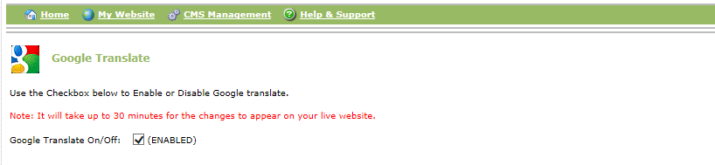
This will display a read only version of Twitter which will display the most recent posts you have tweeted or retweeted.
Adding Google Translate
- Click on My Website.
- Click on Look & Feel.
- Click on Translate Enable and ensure ENABLED box is ticked.
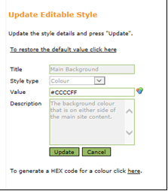
Section 4 – Designing your homepage
- Click on My Website
- Select Look & Feel.
- Click Site Styles.

The Look & Feel section allows you to change certain aspects of the site to give it an individual appearance. The Site Styles option allows you to change things like background colours, font colours, and font.

Changing colours
You can change the colours of the background, site content and text. (See Appendix 1)

Changing Font
You can change the Font within the site if you are on the Responsive 2019 Template (See Appendix 2)

Selecting the area you wish to choose a colour for.
To select a new colour click on the Colour Picker icon to the right of the Value.

This brings up a Colour Picker Dialogue Box, which allows you to select a colour from the grid. Once you have decided on a colour, click Select Colour, then Update.

What is a HEX code?

A computer screen displays colour by mixing red, green and blue light. 100% of all three colours display as white and 0% is black. There are a vast number of colours in between and each one of these is given a specific code depending on the mix of each component - this is the HEX code. A hexadecimal colour is specified with: #RRGGBB. For example, #0000FF is displayed as blue, because the blue component is set to its highest value (FF) and the others are set to 00.#

By clicking on the link you will be taken to an external website, where you can mix your own colour. You may for example, want to exactly match the colour of your nursery’s logo.

The area at the bottom of the screen allows you to alter the size of the general text displayed in the admin site.

To view your website online before it goes live, type in your URL followed by ?bypass=true

For example: http://admin.createitplus.co.uk/?bypass=true

Appendix 1: Look & Feel – Colours

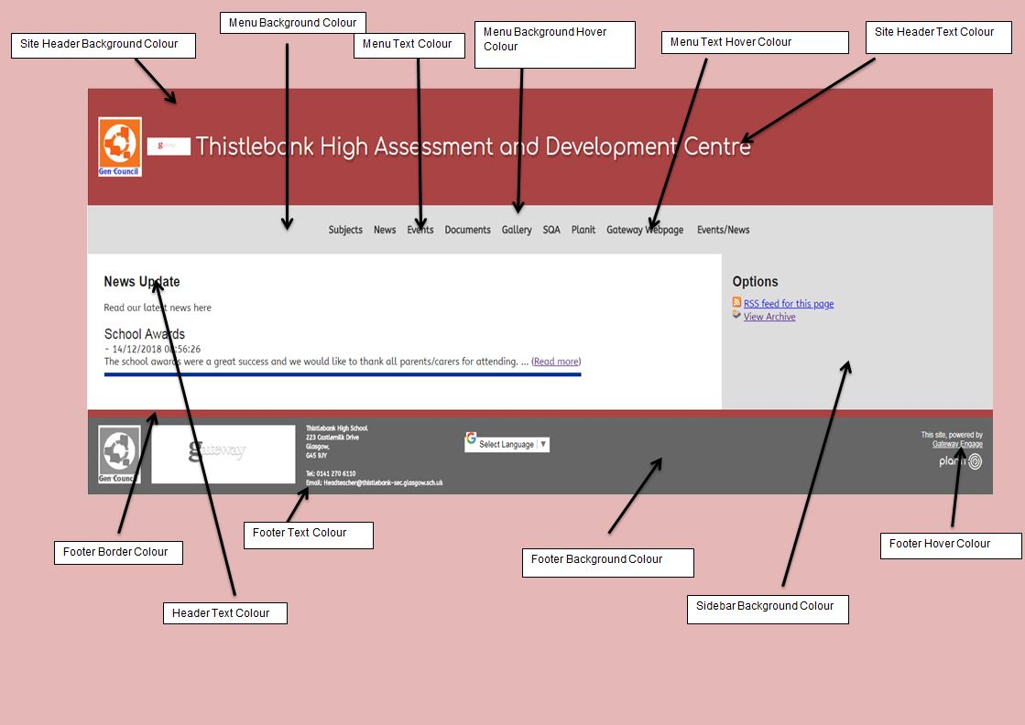

Appendix 2: Look & Feel – Fonts

